General Assembly (Singapore)
Data Analytics Bootcamp (DAB 11)
Topic: Digital Advertising Cost Optimization

Prepared by Jiahong, Zhuo

Contents

Overview 3
Data Information 4
Exploratory Data Analysis (EDA) 5
Purpose 5
Data Quality 5
Univariate Insights 6
Bivariate / Segmentation Analysis & Insights 7
Outlier Detection & Insights 10
Correlation Analysis 11
Predictive Modeling & Insights 12
Model Selection & Rationale 12
Feature Importance & Drivers 12
Model Performance Metrics 13
Segment Analysis & Insights 13
Scenario Analysis 14
Model Assumptions & Limitations 14
Recommendations 15
Methodology Appendix 16

Overview

Audience
This report is prepared for client: Annie Chen (Senior Marketing Manager, Apple Inc.), John (internal Data Analytics Manager, D Advertising Pte Ltd).

Problem
Businesses like Apple Inc. are spending heavily on digital advertising nowadays. However, they are unsure if their advertising dollars are efficiently allocated at the correct advertising audience, locations and digital channels or not.

Goal
The criteria for this report is evaluated based on if there is a significant (at least 10-20%) increase in expected number of online purchases and/or a decrease in the cost per acquisition (CPA) per digital advertising dollar spent by the marketing team.

Approach
My approach to this problem is to make recommendations to enable Apple’s marketing team to better allocate the digital advertising capital to the right audience at the right locations and channels based on analyzing online users’ behaviors across different digital platforms from different locations.

Data Information

Data Source
The data is obtained from fictious advertising performance data from Kaggle. It covers from May to August 2025, including information regarding users’ profiles, advertisement campaigns, advertisement events such as clicks and purchases, as well as the budget and advertisement timings. The data was consolidated into a single dataset to ensure comparability across the various channels.

Data Dictionary Table
Field Name | Definition | Data Type
event_id | Unique identifier for each event | integer
ad_id | Unique identifier for each ad | integer
user_id | Unique identifier for each user | string
timestamp | Exact date and time when the event occurred | string
day_of_week | Day of the week derived from timestamp | string
time_of_day | Time bucket representing when event occurred | string
event_type | Type of user interaction | string
campaign_id | Unique identifier for each advertising campaign | integer
ad_platform | Platform where the ad was served | string
ad_type | Format of the ad | string
target_gender | Gender intended for targeting | string
target_age_group | Age group intended for targeting | string
target_interests | Interests intended for targeting | string
name | Campaign name or label | string
start_date | Campaign start date | string
end_date | Campaign end date | string
duration_days | Total campaign duration | integer
total_budget | Total allocated budget for campaign | float
user_gender | Gender of the user who saw the ad | string
user_age | Age of the user who saw the ad | integer
age_group | Age bucket of the user | string
country | Country where ad was served | string
location | Specific location (city/region) where ad was served | string
interests | Interests of the user who saw the ad | string

Data Cleaning
All the data records were cleaned to remove duplicates, incomplete entries and erroneous data points. Dates were standardized to a uniform format and numerical fields were validated against expected ranges. This ensured the dataset was reliable, consistent, and suitable for analysis.

Data Limitations
While the dataset provides robust insights into digital campaign performance, several limitations should be noted. Online sales data was not available, which a comprehensive digital advertising analysis is unable to be performed. The predictive modeling relied on a relatively short historical time period of four months, limiting the ability to capture longer-term seasonal trends. In addition, the low purchase rate of 0.5% limits the predictive modeling performance score as well. Audience segmentation was restricted by Kaggle, which may not fully reflect comprehensive customer behavior.

Exploratory Data Analysis (EDA)

Purpose
This EDA section was carried out to discover key drivers of advertising performance, validating data quality and identify actionable patterns across different campaigns. This ensures stakeholders can trust the dataset and highlight early insights before advanced modeling stage.

Data Quality
There are approximately 1% of duplicated data which have been removed from the dataset. There are no missing data in the dataset, and dataset has been verified for reasonableness. The datatype of the various categories has been updated to the appropriate data types.

Univariate Insights

Figure 1. Advertising Event Types & Counts
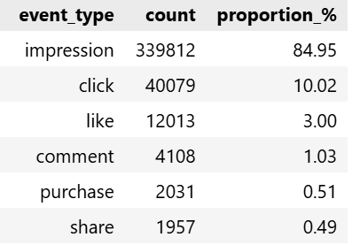
The number of impressions is the highest among all advertisement event types, making up approximately 85% of the total events (refer to above table). The second highest is number of clicks (10%) follow by number of likes (3%).

Figure 2. Histogram of CPA Cost by Age
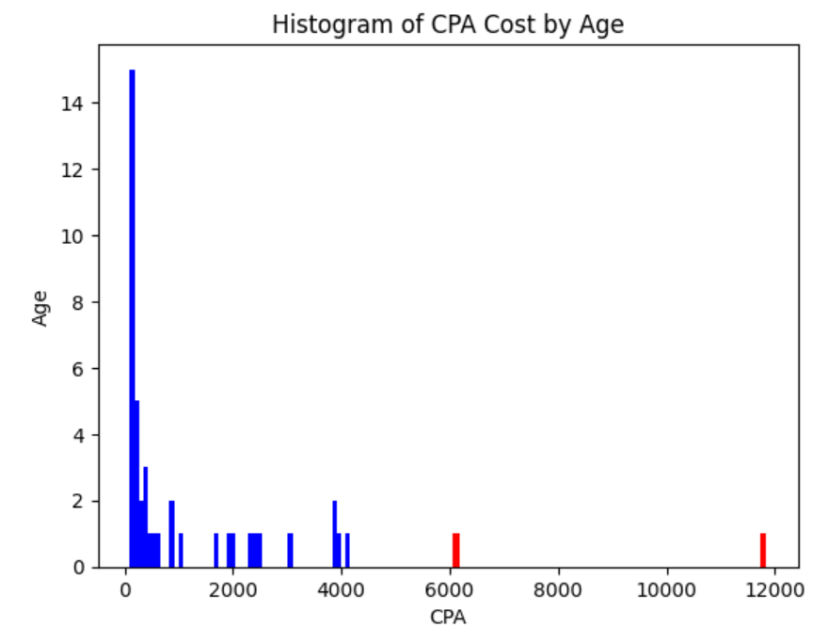
The above table shows that the majority of the digital advertising campaigns’ cost of acquisition (CPA) are low, clustering below $4,000. However, there are a small group of online users showing significantly higher CPA values of above $6,000. This skewed distribution suggests that while the overall digital advertising efficiency is strong, certain age group segments may require adjustment to prevent budget leakage.

Bivariate / Segmentation Analysis & Insights

Figure 3. Impressions & Advertisement Conversion Rate (CR)
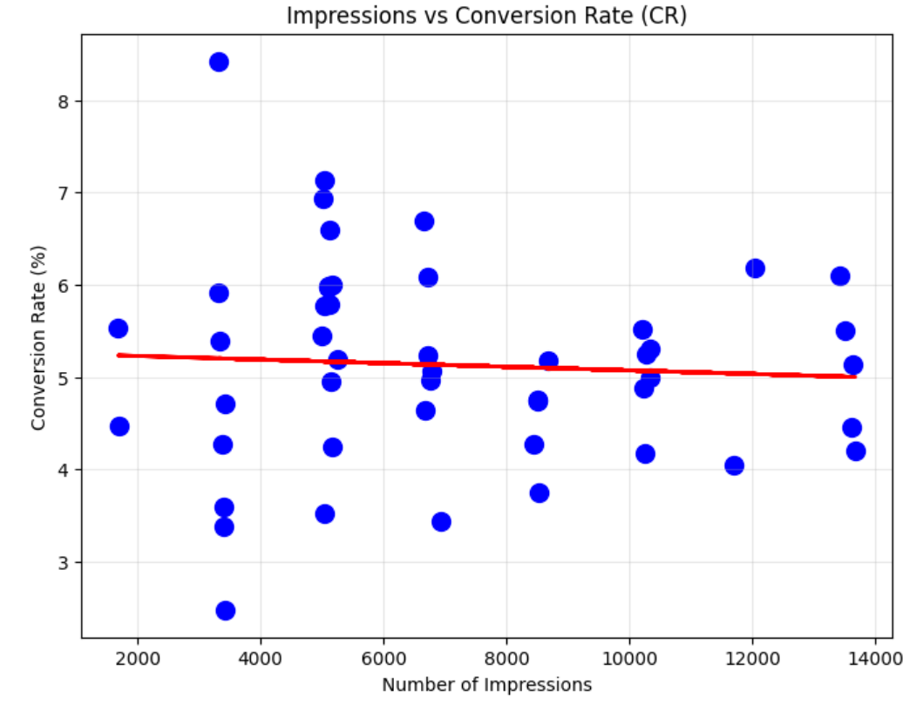
As shown from above figure, there is no clear linear relationship between the number of impressions and advertisement conversion rate (CR). The advertising conversion (purchase) rate ranges steadily from 3-6% regardless of number of impressions. This shows that there is not much benefits for business to scale up their digital advertisements since there is no increase in CR at higher number of impressions.

Figure 4. Relationship between Country & CR, CPA, CTR
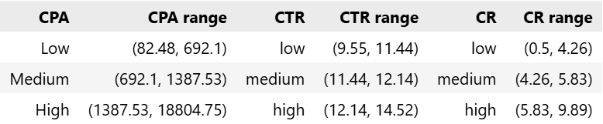

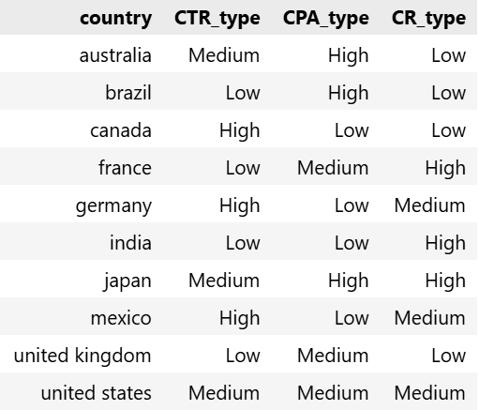
Based on the above figure, countries such as India, Mexico and Germany have low CPA cost, medium to high conversion rate (CR). Business can allocate more advertising budget to these countries and reduce allocation to countries such as Australia and Brazil which have high CPA cost and low CR.

Figure 5. Relationship between CPA & Advertisement Type
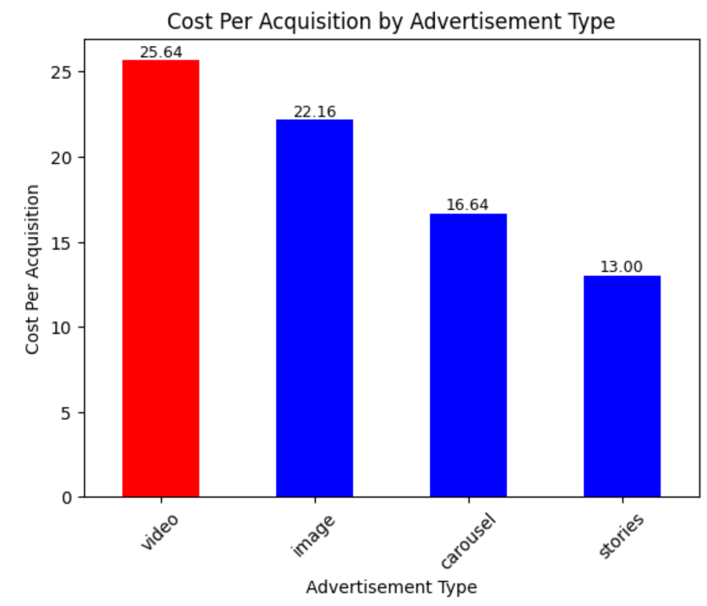
The median cost of acquisition (CPA) per ad type is the lowest at $13 for Story advertisement type, and highest at $25.64 for Video advertisement type (refer to above figure). Hence, business can re-allocate more advertising budget from video to story advertisement type to be more cost efficient.

Figure 6. Mismatch of Target & Actual age groups
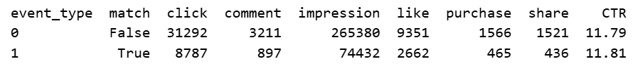
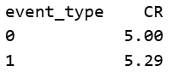

There is a high proportion (78%) of mismatch between target and actual age groups of online users. This means that any age group segmenting targeting strategy is most likely ineffective, even though the conversion (CR) and click through rates (CTR) of both groups (match = event type 1, mismatch = event type 0) are similar (refer to above table).

Outlier Detection & Insights
Figure 7. Relationship between Advertising Budget & CPA per ad
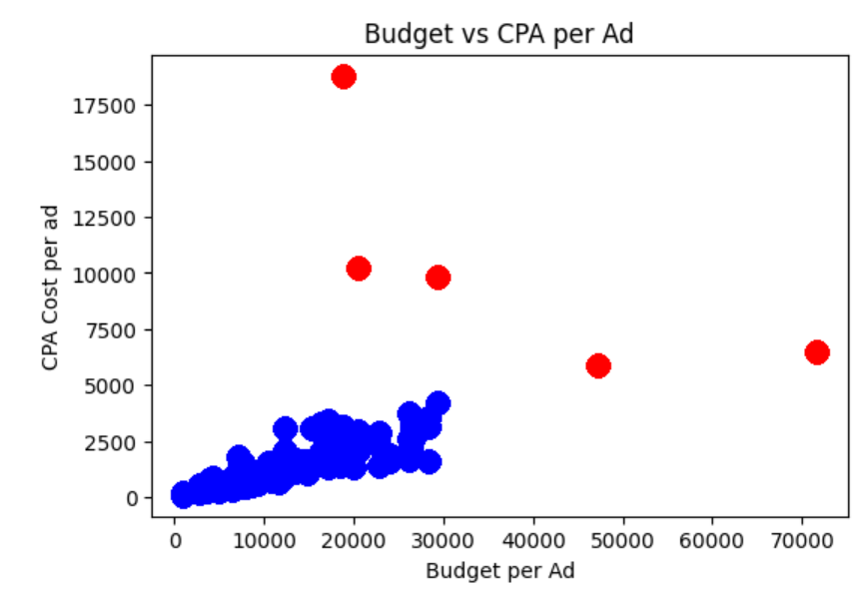
Figure 8. CPA Breakdown by Country
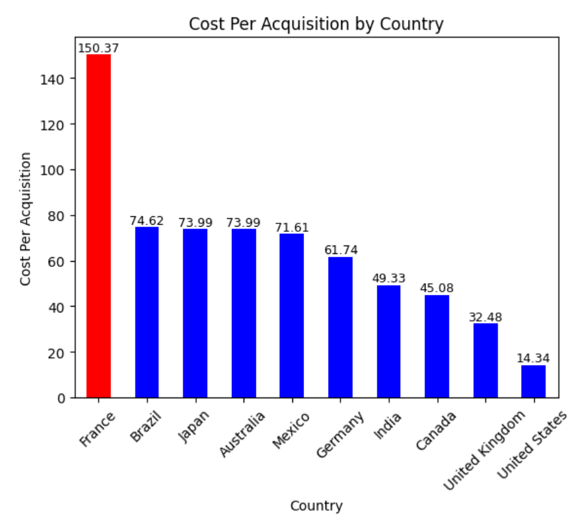
There is a small group of users whose CPA is significantly higher than the majority of the other online users (refer to red dots in above figure 7). This maybe due to the ad targeting at France users who have a significantly higher CPA cost as compared to other countries (see above figure 8). Hence, they are the outlier group compared to other users.

Correlation Analysis
Figure 9. Correlation between 4 categorical features
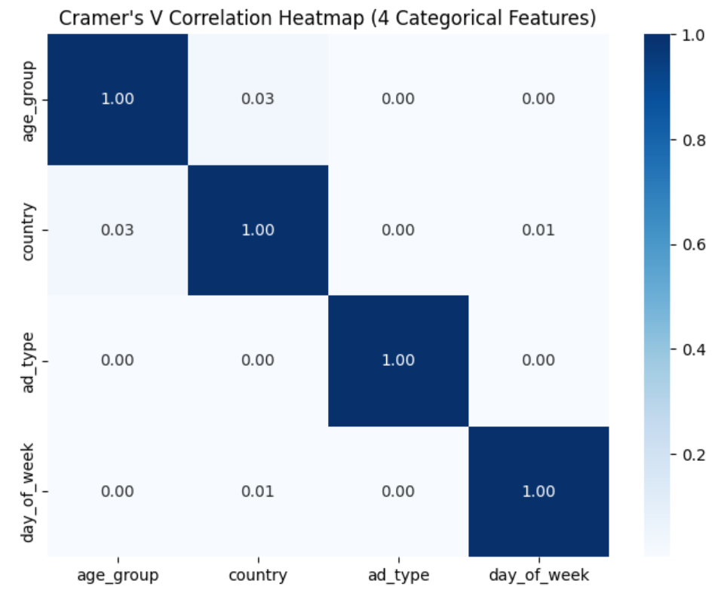

Figure 10. Correlation between Probability of Purchase & 4 categorical features
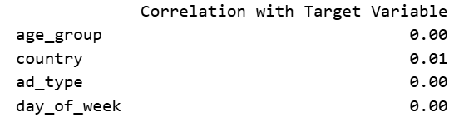
The correlations between the 4 categorical features (age group, country, ad type, day of week) and 2 numerical features (CTR, CPA) are very low of less than 0.1. In addition, the correlation between target variable and categorical features are also very low at 0.01 (see above). This shows that there is no multicollinearity issue among the features. However, these low correlations are also likely due to the low purchase rate (class size) of 0.5%.

Predictive Modeling & Insights

Model Selection & Rationale
The logistic regression model is being chosen due to its ability to handle large datasets that consists of a mix of categorical and numerical features, as well as a binary target (purchase) variable. In addition, the model can train and predict faster and needing lesser computing power as compared to other similar models such as random forest.

Feature Importance & Drivers
Figure 11. Coefficients & Odds Ratio of Logistic Regression Model
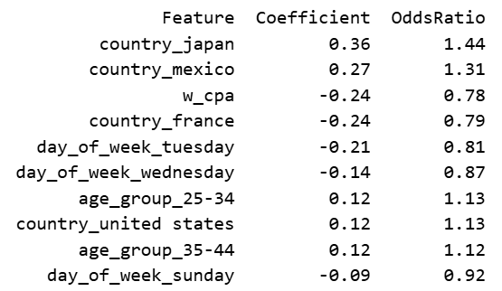
Features such as Countries and CPA have the strongest relative influence on Target Variable (Probability of Purchase) as shown from above table. Days of the week and age group features have weak to moderate relative influence. Businesses should increase digital advertising targeting at countries like Japan and Mexico as every unit increase in these countries will result in an increase of 36% and 27% in the probabilities of purchase on the online users respectively. In addition, businesses should reduce the CPA as an increase in CPA will reduce the probability of purchase on the online users.

Model Performance Metrics
Figure 12. Logistic Regression Model Performance Metrics
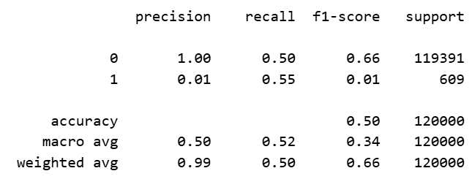
The logistic regression model achieves macro average performance scores (precision: 0.50, recall: 0.52, f1: 0.34, accuracy: 0.50) as per above table. These scores are not considered high, means the approximately half of the model’s predictions are true. The extremely low precision score of 0.01 for the minority class (1) is due to the low purchase rate of 0.5% (imbalanced class size).

Segment Analysis & Insights
Figure 13. Expected CPA by Country
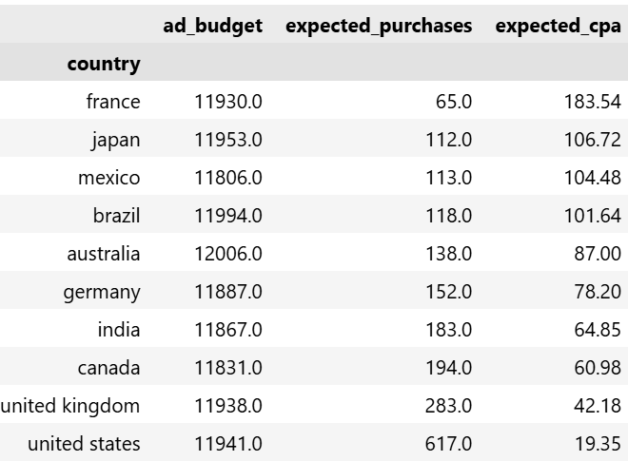
The top three countries with the lowest expected cost of acquisition (CPA) are United States ($19), United Kingdom ($42) and Canada ($61). The median expected cost of acquisition (CPA) of the countries segment is calculated to be $82.60. Businesses can re-allocate their digital advertising budget to focus on those countries whose CPA are below the median CPA cost.

Scenario Analysis
Figure 14. Increasing CPA by 10% on Probability to Purchase
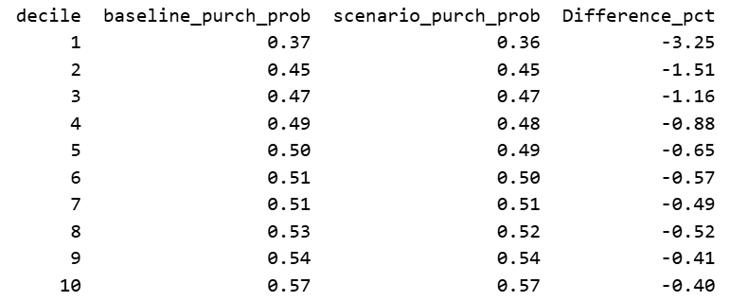
Increasing CPA by 10% will reduce the probability of purchase from -0.40% to -3.2% at every decile (refer to above) even though the overall mean probability to purchase is unchanged due to low purchase rate (0.5%). As such, this shows that businesses should reduce their average CPA in order to result in higher chance of purchase on their products.

Model Assumptions & Limitations
The above logistic regression model assumes that online users’ behavior patterns are representative of the behavior of the real world’s online users’ population, and market conditions will remain unchanged over time. Another assumption is that the target purchase variable is only linearly related to the features of the model, which are also assumed to be independent of each other.
There are several limitations, namely the 0.5% purchase rate (due to highly imbalanced dataset) may result in predictions that overstate non-purchase outcomes. On top of that, the four-month time period of the dataset limits visibility of seasonal or long-term digital advertising trends. In addition, the absence of revenue data of advertisements limits the coverage of the digital advertising analysis. Last but not least, the high mismatch of the target group segments limits the value of the age group segment analysis.

Recommendations

Optimize low-cost & high purchase segments
Businesses can pause digital advertising spending on video advertising type (lowest expected number of purchases), and re-allocate the advertising budget to stories advertising type (highest expected purchases). This will result in a 18% increase in expected number of purchases (conversion) with the same amount of budget.
Furthermore, businesses can also re-allocate their digital advertising budget from high cost per acquisition (CPA) countries such as France and Mexico to countries that have high conversion rates and low expected costs of acquisition (CPA) such as United States, Germany & India. In this way, businesses can reduce their expected CPA by 2.6 times, from $623 to $234, which significantly increase their digital advertising cost efficiency.

Data Improvements
Digital advertising revenue data should be included for more comprehensive analysis involving Return on Investment. In addition, longer time period data should be provided to allow for seasonality and longer-term advertising trends.
In addition, advertising companies like us should improve our target group data validation process to reduce the significant target age group mismatch issue. Consequently, businesses can deploy age group segment advertising strategies more effectively.

Model Improvements
Due to the large imbalanced class size (purchase rate of 0.5%), the highest macro average precision and recall score of logistic regression model is only 52% which is not considered high. As a result, a second model, Light GBM, was being used and evaluated against the first model. Despite having a high recall score of 99%, its precision and F1 scores are very low 1% respectively.
This unbalanced recall-precision score of the Light GBM model leads to the conclusion that first model is more appropriate. More in-depth tuning of the model’s hyper parameters can be performed which may improve the performance scores of both models.

Methodology Appendix

Metric Definitions
Click Through Rate (CTR) = Clicks / Impressions * 100
Conversion Rate (CR) = Purchases / Clicks * 100
Cost Per Acquisition (CPA) = Campaign Advertising Budget / Purchases * 100

Data Source
This report obtains the fictitious dataset from Kaggle, an open data source website.

Tools & Environment
This report adopts SQL (structured query language) for joining of data tables. In addition, the report use python (pandas & scikit-learn) for data cleaning, exploratory data analysis, modeling and visualization for stakeholder reporting.

